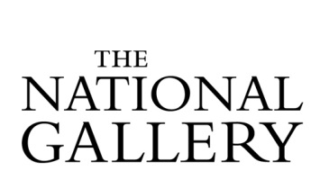

SSN Study Day
Thursday 20 September 2018, 11.00 - approx. 16:30
Scottish National Gallery, The Mound, Edinburgh, EH2 2EL

BOOKING FORM
To book a place please email your completed booking form by Thursday 13 Sept. 2018 to: ssn@ng-london.org.uk

Your details
Name
Role
Organisation
Email address
Will be included on the delegate list.
Contact phone number
For office use only

Please note
Photographs and audio/video recordings may be taken during the event on behalf of the venue and the SSN/The National Gallery. The copyright for this material will remain with the organisers. Images and recordings may be used on the organisers’/the SSN’s websites, social media feeds, advertising materials and reports to illustrate the work of the SSN as a professional network. If you do not wish to be included in images/footage please email ssn@ng-london.org.uk

Special dietary requirements:

Other requirements:

Are you applying for a travel bursary?
Travel bursaries are issued on a first come, first serve basis.

☐ No ☐ Yes – Please provide details on the next page

Travel bursary application – SSN Study Day

Travel costs must be based on the most cost effective travel option. Where support is confirmed by email, delegates will make their own travel bookings. Reimbursement of the agreed sum will be made by after the SSN member has attended the event.

Event Title & Date:
SSN Study Day ‘Rembrandt & Britain’, Edinburgh, Thursday 20th September 2018

Delegate name & Organisation:

Reason for travel bursary application:

Details of travel (means of travel, to/from, dates) and breakdown of costs:

