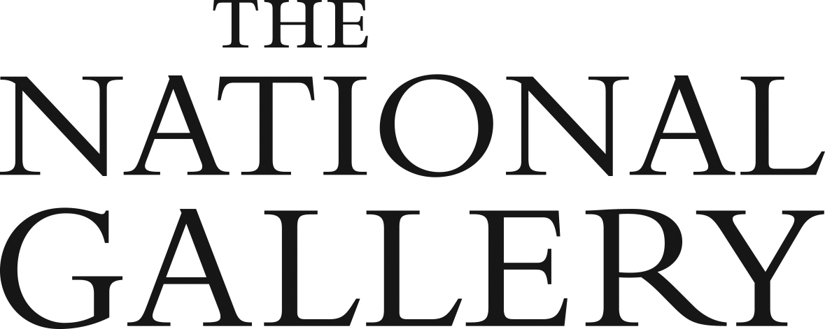

SSN Collections Research Grants

2019–20
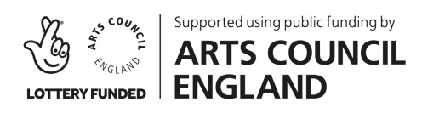
Supported by Arts Council England

Application Form

Part 1

Applicant Information

Organisation

Address

Legal status of the organisation

(for example local authority museum, independent trust, university museum)

Main contact

(name, job title, email address,

telephone number)

Part 2

Project proposal, including milestones and outcomes

Please describe the proposed research project and provide details of the following:
- Which painting(s) would be the subject of the project;
- How the research would be undertaken (methodology, sources, research trips, etc.);
- How the project would help extend knowledge about historic European paintings (non-British, 13th – early 20th century) in your collection;
- What public outcomes the research project would help you deliver, why these outcomes would be beneficial to your community/audiences and/or how they may help facilitate access to your collection;
- A draft timescale with envisaged key milestones.

Part 3
Project resource

Please specify who would be undertaking the research project. If you are planning to appoint an external researcher or use the grant for short-term backfill please give further details

Part 4
Project budget

Please specify the amount (up to a maximum of £1000.-) that you are applying for and provide an estimated breakdown of project costs.

Part 5
Supporting materials (optional)

Please feel free to provide additional information in this section or as an attachment.

Please note that attachments should not exceed 1 MB. For images we recommend using a file transfer service such as WeTransfer. Alternatively you are welcome to request a file transfer link from the National Gallery.

Before submission
For an informal conversation or any questions please contact:
Flavia Dietrich-England, National Programmes Manager, flavia.dietrich-england@ng-london.org.uk

Submitting your application

Please submit this application and any supporting materials (if applicable) by midnight on Friday 1 November 2019 to the following email address:

ssn@ng-london.org.uk

We will aim to notify you of the outcome of your application in mid-November 2019.

