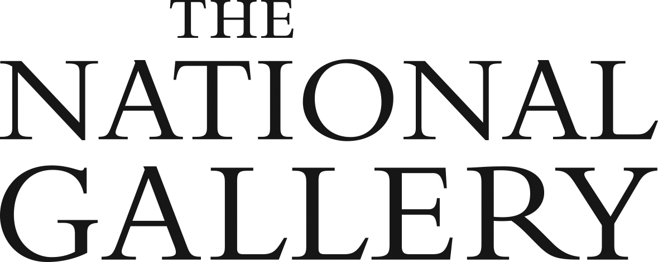

The National Gallery Curatorial

Traineeship Programme 2019–21
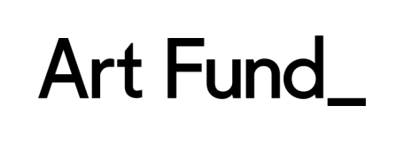
Supported by Art Fund with the assistance of the Vivmar Foundation

Application Form for UK Museum Partners

Part 1

Applicant Information – Contact details

Name of Museum or Lead Organisation

Address

Main contact

(name, job title, email address,

telephone number)

Second contact

(name, job title, email address,

telephone number)

Part 2

Applicant information – Organisation type & status

Legal status of the organisation

(for example local authority museum, independent trust, university museum)

Accreditation number

(If Accreditation in process, please supply brief details.)

Number of visitors per year

Brief description of main collections, particularly of the paintings collection relevant to the proposal

Does the museum charge for admission?

Brief description of any grants exceeding £100,000 (for example grants for capital projects or major acquisitions) received by the museum or lead organisation in the last 5 years

Part 3
Capacity during envisaged placement period (up to approx. 200 words)

Please provide brief details of the following:

- Who would be the main contact, source of support and project supervisor for the Curatorial Trainee during their placement at your organisation (at least one full-time member of staff or two members of staff job sharing)?
- What experience of supporting/mentoring a member of staff in the early stages of their career do(es) the main contact(s) have?
- Who else in your organisation would be available to support the Trainee and the project?
- Where would the Trainee’s main workspace be located, and what equipment would this work area include?

Part 4
Project proposal (max. 1000 words)

Please describe the project that the Curatorial Trainee would be working on, addressing how it meets the following criteria:

- Explores and makes accessible an aspect of your organisation’s collection of European paintings (approx. up to 1900);
- Enables the Curatorial Trainee to develop key curatorial skills, providing them with a strong foundation for their future career;
- Delivers one or more public outcomes;
- Delivers benefits for your organisation and your audiences, beyond the duration of the Programme and the delivery of immediate outcomes.

If you would like to work more closely with the National Gallery on the development of public outcomes please state this here, including details of the areas in which you would welcome support.

Part 5
Commitment to diversification & promotion of Programme (bullet points suffice, up to approx. 100 words)

Please describe briefly how you intend to support the promotion of the Curatorial Traineeship Programme as a pathway for a wide range of applicants within your own area and networks and beyond.

Part 6
Supporting materials (optional)

You may submit up to two appendices to support your application.

Please note that when sent attached to an email the total file size of your application should not exceed 1 MB. If your supporting materials contain many images, please send this part of your application using a file transfer service such as WeTransfer or request a file transfer link from the National Gallery.

Please list any supporting materials briefly below, indicating whether you are attaching them or sending them via separate file transfer:

Submitting your application

Please submit the Museum Partner Application Form and any supporting materials (if applicable)
by 5 pm on Tuesday 7 May 2019 to:

Dr Flavia Dietrich-England
National Programmes Manager
The National Gallery
Trafalgar Square
London WC2N 5DN
flavia.dietrich-england@ng-london.org.uk
T: 020 7747 2514
M: 07770 646 524

Please feel free to get in touch for an informal conversation and to discuss any questions before submitting your application.

