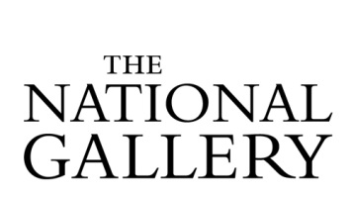

SSN Study Day
Thursday 28 June 2018, 11.00-16.00
Cannon Hall Museum, Park and Gardens Bark House Lane, Cawthorne, Barnsley, S75 4AT

BOOKING FORM
To book a place please email your completed booking form by Friday 15 June 2018 to: ssn@ng-london.org.uk

Your details
Name
Role
Organisation
Email address
Will be included on the delegate list.
Contact phone number
For office use only

Please note
Photographs and audio/video recordings may be taken during the event on behalf of the venue and the SSN/The National Gallery. The copyright for this material will remain with the organisers. Images and recordings may be used on the organisers’/the SSN’s websites, social media feeds, advertising materials and reports to illustrate the work of the SSN as a professional network. If you do not wish to be included in images/footage please email ssn@ng-london.org.uk

Special dietary requirements:

Other requirements:

Are you applying for a taxi place from Barnsley Station to Cannon Hall Museum?
Places are allocated on a first come, first serve basis. Details of taxi transfer will be confirmed in a separate email.

☐ No ☐ Yes

Are you applying for a travel bursary?
Travel bursaries are issued on a first come, first serve basis.

☐ No ☐ Yes – Please provide details on the next page

Travel bursary application – SSN Study Day

Travel costs must be based on the most cost effective travel option. Where support is confirmed by email, delegates will make their own travel bookings. Reimbursement of the agreed sum will be made by after the SSN member has attended the event.

Event Title & Date:
SSN Study Day at Cannon Hall Museum, 28 June 2018

Delegate name & Organisation:

Reason for travel bursary application:

Details of travel (means of travel, to/from, dates) and breakdown of costs:

